Document Title :

Technical P.O Specification
for Air Conditioning System

Project:
{{loop test}}{{a}} |  |  |  |  |  |  |  |  |  |  | {{endloop}}
-
Rev. | Status | Date  (DD.MM/YY) | Description |  |  |  | Prepared by |  |  | Checked by | Approved by
  Contractor Logo |  |  |  |  |  | Company Logo
SHI Project Number: |  |  |  |  | Facilities: |  |  |  | SFI Code:
Contractor Document Number |  |  |  | - |  |  |  | Rev. No. |  |  |  | -
Company Document Number |  |  |  | - |  |  |  | Rev. No. |  |  |  | -
Design discipline |  |  |  | ACCOMMODATION DESIGN |  |  |  | As-Built (Y/N) |  |  |  | N
SAMSUNG HEAVY IND. CO., LTD.GEOJE SHIPYARD, KOREA
This document is the property of SAMSUNG HEAVY IND.CO., LTD. and must in no case wholly or partially be copied, shown or given to a third party without SAMSUNG's consent.

Revision Record

Revision Log
Rev | Section | Description of Revision
0 | All | First issue for review.

INTRODUCTION

GENERAL REQUIREMENT

Rules, Regulation and General Specification

Responsibility

HVAC DESIGN CRITERIA

Plant capacity design conditions.
Cooling
Heating

Heating, Humidification, Cooling medium and Fresh/Return air.

Refrigerating plant and AHU location.

Deck height and ceiling height.
.

Heat dissipation
Heat dissipation, kW

Type of Ventilation and Air change rate

Noise level

Operation guide of HVAC system for loading and unloading

SCOPE OF SUPPLY

Air conditioning system

A/C Refrigerating plant
.
Component | Specification |  |  | Remarks

4.1.1.1 Compressor controls and fittings

4.1.1.2 Condenser controls and fittings

Central Air Handling Unit

Component | Specification |  | Remarks

HVAC Control panel (If apply to PLC)

Temperature control
In summer:

In winter:

In intermediate seasons:
.

Re-heater :

Mechanical ventilation fans

Supply ventilation fans
No. | Served space | Qty | Remarks | Application
1

Extract ventilation fans
No. | Served space | Qty | Remarks | Application

Separate air conditioning unit (PACU)

Galley PACU
Q’ty/ship

Electrical equipment room PACU

Cargo switchboard room# 1.

Cargo switchboard room# 2.
Q’ty/ship
Capacity
Air discharge
Function
Cooling water
Refrigerant
Air flow
Max. Noise level
Location

Air distribution and Ducting

Piping

Lubricating oil and refrigerant

Spare parts, Tools and Identification plates

Drawings and Documents

EQUIPMENT AND INSTRUMENTS GENERAL REQUIREMENTS

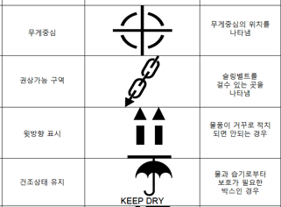
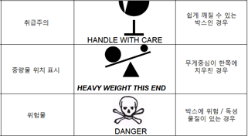

Inspection and function Test

Miscellaneous (if required)

