# Cad File System

## Cad File Structure

CAD file system is having tree like structure file with cad main file having other type of file as referance

And it can have other cad file as a refarence and main cad will be holding all the files as refarence.

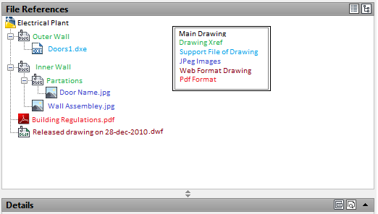

AutoCAD Object Modal

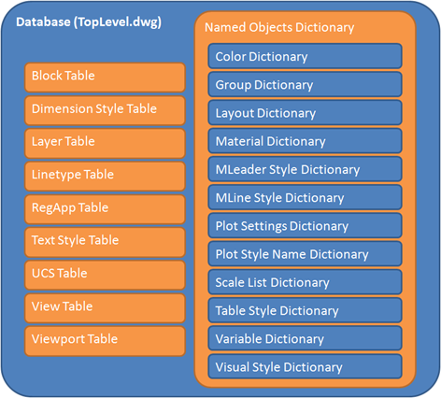

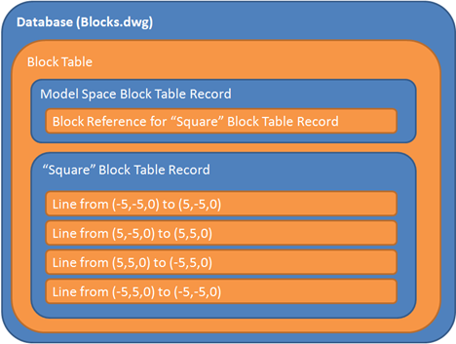

AutoCAD Object Modal At application Level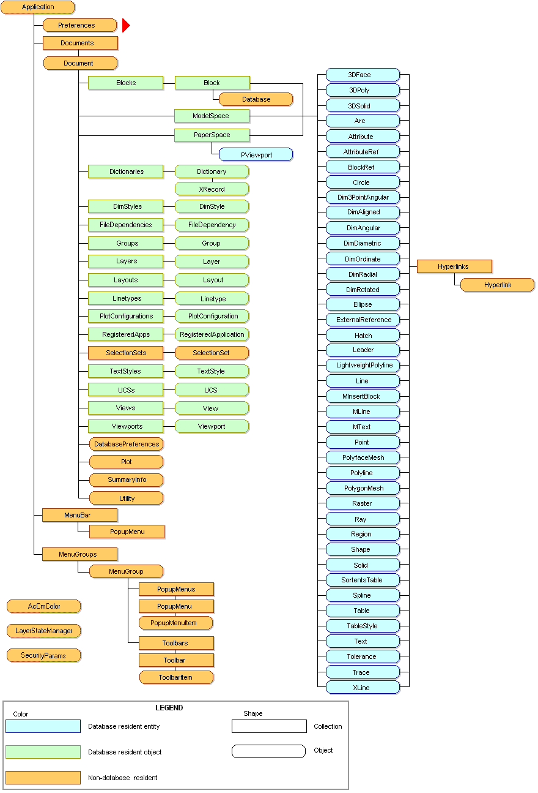

# Intial Setup and UI Concept

## Setup Client Concept

ProArc AutoCAD Integration.

ProARCApplication.Dll PROARC

A

ProArc

Autodesk API

Ribbon Bar and Dialog Box

Application

Documents

Tables

Objects

AutoCAD Database.

Proarc Client side integration dll will be developed using .Net and Autodesk API dll which will accessing and managing the information between PROArc and AutoCAD Document Database.

All the dll will be developed using .net c#

## Environment Setup

The following blog contains detailed information how to set up a AutoCAD Environment for .NET Support