1. Open document and first modification :

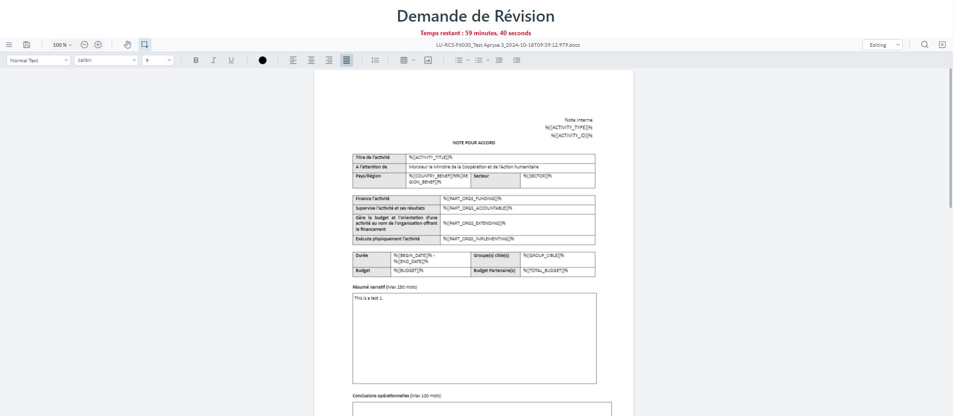

1. Save and close document, reopen document and second modification :

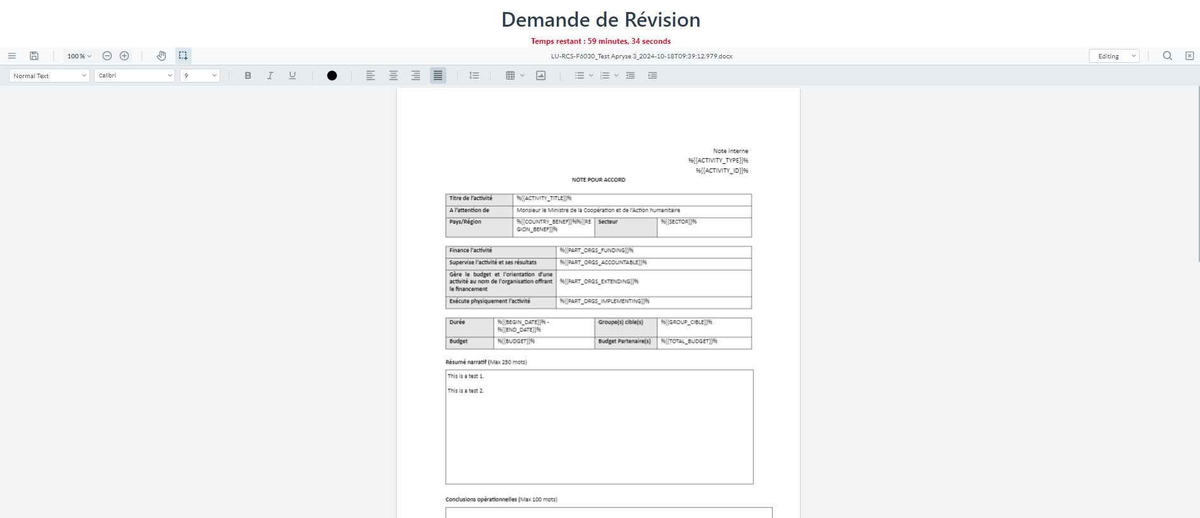

1. Save and close document, reopen document : first modification disappeared

