|  |  |  |  |
| --- | --- | --- | --- |
| **Project Information** | | | |
| **Project Name:** | RSIC Stage 2 von Haast Building | **Date:** | 27 August 2017 |
| **Project Number:** | DC-1871 | **Client:** | University of Canterbury |
| **Site Address:** | Forestry Rd | **Supervisor:** | Keegan Hewlett/ Gary Butterfield |

|  |
| --- |
| **Summary of works** |
| **L3 North Enclosure 3&4**  All 80 % completed awaiting service disconnection to sandblast the risers and heater voids  **Contaminated ceiling and wall** **Risers** Rooms 312, 312a, 313,315, 316, 317, 319, 320, 323, 325, 326,329, 330, 331, 335, 337, 339 (70 % completed)  **Floor tiles** Rooms 315, 317, 319, 329, 335, 339, 330, 326, 322, 312, 312A (All completed)  **Heaters** throughout have been completed  Precise Consulting have been carrying out air monitoring outside the DCU and NPU with results showing no elevated fibre counts  **L3 South Enclosure 1, 2, 3, 4**  All 80 % completed awaiting service disconnection to sandblast the risers and heater voids  **L2 North Enclosure 1, 2, 3, 4**  Soft strip completed and all windows and open risers sealed off with 250 micron PVC  **L2 South Enclosure 5, 6, 7, 8**  Soft strip completed and all windows and open risers sealed off with 250 micron PVC  **L1 North Enclosure 1, 2, 3, 4**  This area has been used for the storage of a large quantity of furniture type waste and will be loaded out via the loading Dock on the East side  **L1 South Enclosure 5, 6, 7, 8**  Soft strip completed and all windows and open risers sealed off with 250 micron PVC  **BASEMENT**  All internal structures and materials have been demolished or broken down into a manageable size for wrapping . The majority of the week was spent wrapping contaminated waste parcels in 250 micron PVC.  All demolition waste has now been wrapped and stored.  As power will be isolated next week we can then remove plumbing and wiring off the walls and ceiling  **PLANT ROOM L1 119**  At this stage the clean involving a Hepa Vacuum, wet wiping and a final tac-rag wipe of all surfaces including pipe work has been completed. The assumed pipe Gaskets will be removed as part of the de-construction but we have sealed the gaskets. When removing, we will simply be cutting either side of the pipe join so we do not disturb the gasket joins.  Precise will be on site Monday to undertake a visual inspection followed by Airborne fibre monitoring test. |

|  |
| --- |
| **Site Notes** |
| *Incidents & accidents, variations, damage, material requests, delays, visitors to site etc.* |
| \*Precise Consulting on site daily to install outside air monitoring of the NPU and DCU  \*We will need to get The Gas Guys engaged to work with us to do the physical gas pipe cut since they can’t guarantee pipes to be free of LPG  \*Meeting was held with Tony (UoC Electrical) and Brendan of C&L to determine how to safely provide site temp power for Level 1,2 and 3 and when to cut permanent power to von Haast feed from the SBS Basement  \*Precise conducted further swab testing in L1 &2 in the wall Risers and adjoining ceiling spacers. It was also decided to do further testing of the white painted ceiling panels which has had Whisper coat removed in the past. Concern about, how and when this was removed to understand how clean the concrete is. Historically it was acceptable to bond after removal has taken place, however now as a Demolition, we need to know from a waste and potential environmental point of view.  . |

|  |  |
| --- | --- |
| **Site Staff** | |
| **Staff Name:** | **Work Area & Works Carried Out:** |
| Keegan Hewlett (COC) | Level 3 North and Plantroom 119 |
| Bernard Ryan | Plantroom 119, Set up |
| Karl Petersen | Loading of waste (Digger) |
| Shannon Ngaronga | Level 3 North Sandblasting prep |
| William Thomas | Level 3 North Sandblasting prep |
| Helena Reynolds | Plantroom 119, Set up |
| Vince Balatero | Plantroom 119, Set up |
| Bradley Nel | Level 3 North Sandblasting prep |
| Cameron Parnell | Level 3 North Sandblasting prep |
| Nikola Karanas | Level 2 strip out |
| Semisi Niupalau | Level 2 strip out |
| Tautahi (Tee) Kiveka | Level 1 strip out |
| Jacob Edmonds | Carrying waste to loading dock |
| Tim Verplanke | Level 1 strip out |
| Juan Labarerra | Carrying waste to loading dock |
| Jordan Preece | Level 2 strip out |
| Dayne Robinson | Carrying waste to loading dock |
| Rachel Fitzpatrick | Plantroom 119 |
| Gary Butterfield (COC) | Level 2 |
| Wayne Riley | Level 2 |
|  |  |
|  |  |
| Richie Edwards (COC) | Basement |
|  | Basement |
|  | Basement |
| Quentin Murphy | Basement |
| Logan McMurtrie | Basement |
| Storm Campbell | Basement |
| Jake Murphy | Basement |

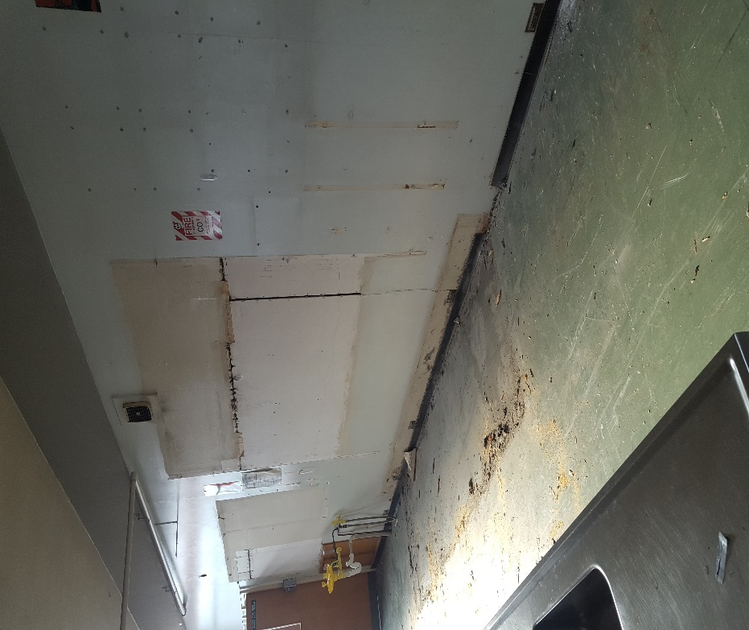

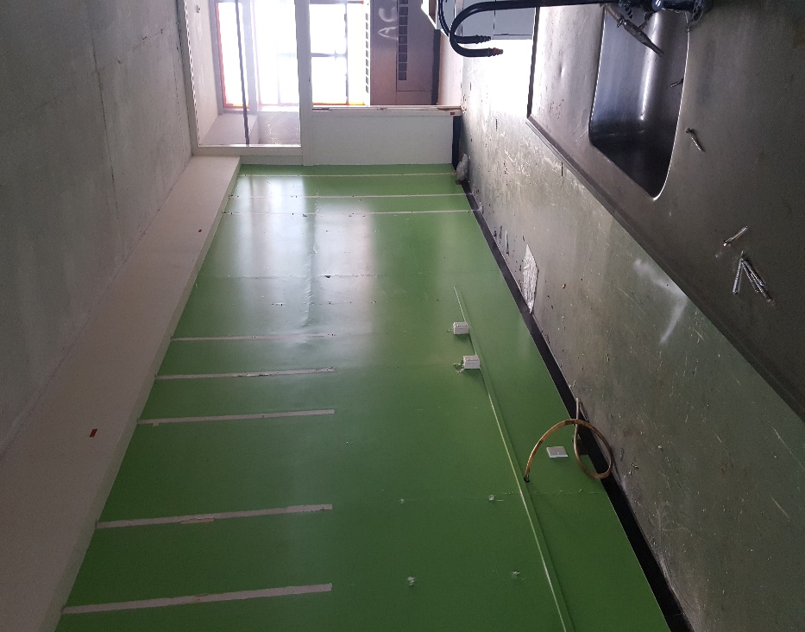

**Level 1 and 2 strip out, before setting up enclosures, sealed areas with ACD contamination**

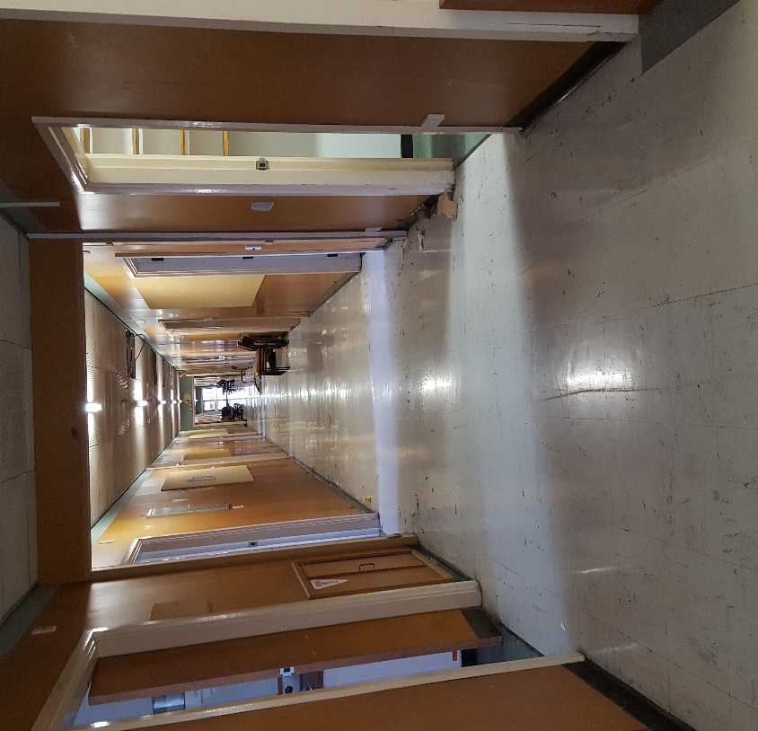

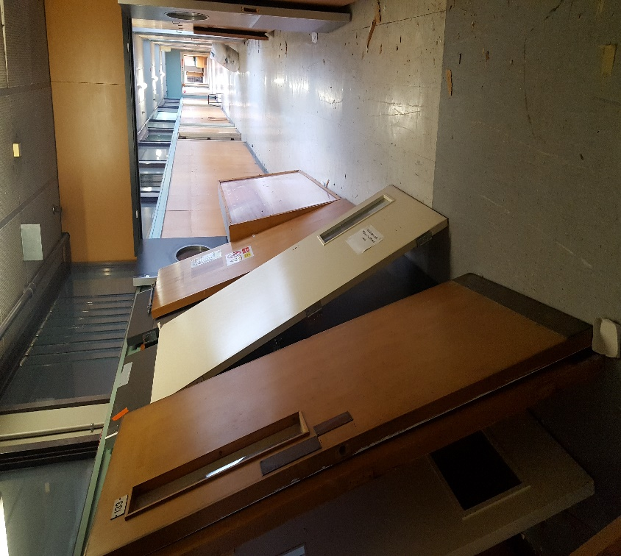

|  |
| --- |
| **Photos:** |
| ImageImage    **Plantroom 119 NPU set up**  ImageImage  **Level 3 North during the asbestos removal, bagging of ceiling tiles and protection of clean ceiling areas**  ImageImage  C:\Users\richard.lines\AppData\Local\Microsoft\Windows\INetCache\Content.Word\20170825_133539 (002).jpgC:\Users\richard.lines\AppData\Local\Microsoft\Windows\INetCache\Content.Word\20170825_133805 (002).jpg          **Basement Photos**  C:\Users\richard.lines\AppData\Local\Microsoft\Windows\INetCache\Content.Word\20170825_134736 (002).jpgC:\Users\richard.lines\AppData\Local\Microsoft\Windows\INetCache\Content.Word\20170818_114945 (002).jpg    **Basement waste**  C:\Users\richard.lines\AppData\Local\Microsoft\Windows\INetCache\Content.Word\20170825_134736 (002).jpg  **Wrapped waste in 250 micron PVC**  C:\Users\richard.lines\AppData\Local\Microsoft\Windows\INetCache\Content.Word\20170825_134724 (002).jpg  C:\Users\richard.lines\AppData\Local\Microsoft\Windows\INetCache\Content.Word\20170825_133523 (002).jpg    **COMING WEEK….**     * Removal of all Pipes in L3 North 3 &4 enclosures, and South 1 & 2 * Continue with the removal of ACD from the Basement * Confirm Isolation of Services in basement and L1,2 and 3 * Work with The Gas Guys to remove gas pipes L3 first * Load out of clean waste from Level 1 & 2 into Waste Management skips * Precise final visual and Air test (Monday) for the Plantroom 119 * Continue with enclosure set up in L1 North & South and L2 North & South |